Chapter 3
SYSTEM DESIGN
3.1 Tables Description
The following tables were used in our project:

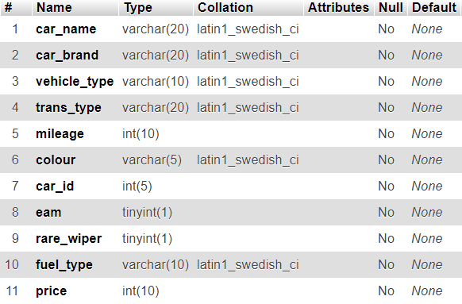
Fig 3.1 Car Table
The above figure 3.1 shows the design of car table. It stores all the data related to cars.

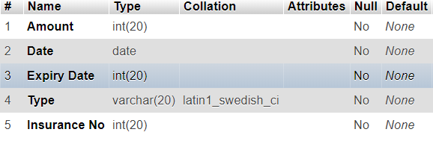
Fig 3.2 Insurance Table
The above figure 3.2 shows the design of Insurance table. It stores all the data related to insurance.

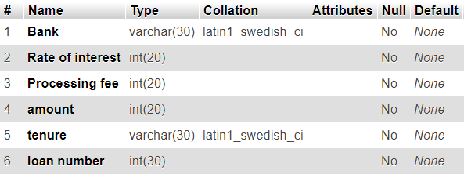
Fig 3.3 Loan Table
The above figure 3.3 shows the design of Loan table. It stores all the data related to loan.

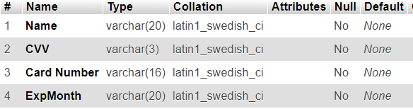
Fig 3.4 Payment Table
The above figure 3.4 shows the design of Payment table. It stores the data related to payment.

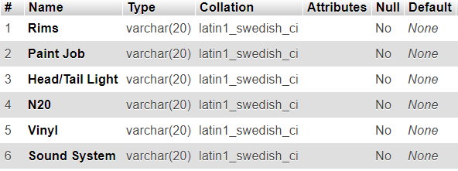
Fig 3.5 Recast Table
The above figure 3.5 shows the design of Recast table. It stores all the data related to recast.

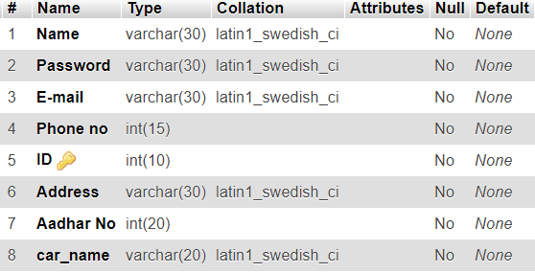
Fig 3.6 User Table
The above figure 3.6 shows the design of User table. It stores all the data related to user.

